**SUPPORTING INFORMATION**

**Advanced data preprocessing for Comprehensive two-dimensional Gas Chromatography with Vacuum Ultraviolet Spectroscopy detection**

Aleksandra Lelevica,b,*, Vincent Souchona, Christophe Geantetb, Chantal Lorentzb, Maxime Moreauda,*

1. IFP Energies nouvelles, Rond-point de l'échangeur de Solaize BP 3 69360 Solaize France
2. Univ Lyon, Université Claude Bernard Lyon 1, CNRS, IRCELYON, F-69626, Villeurbanne, France

* Author for correspondence: [aleksandra.lelevic@ifpen.fr](mailto:aleksandra.lelevic@ifpen.fr),  [maxime.moreaud@ifpen.fr](mailto:%20maxime.moreaud@ifpen.fr)

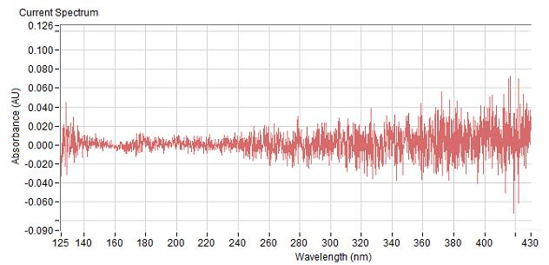

Figure S1 Measured detector blank spectrum.

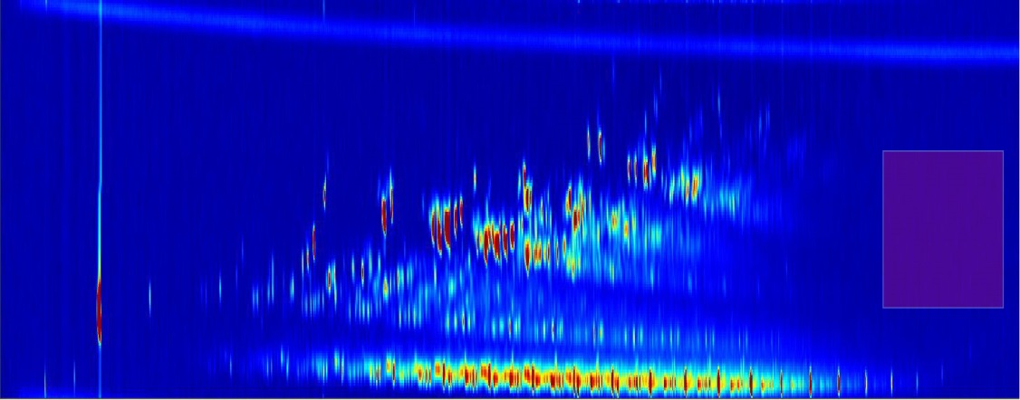

Figure S2 Selection of a zone for extracting detector blank signal.

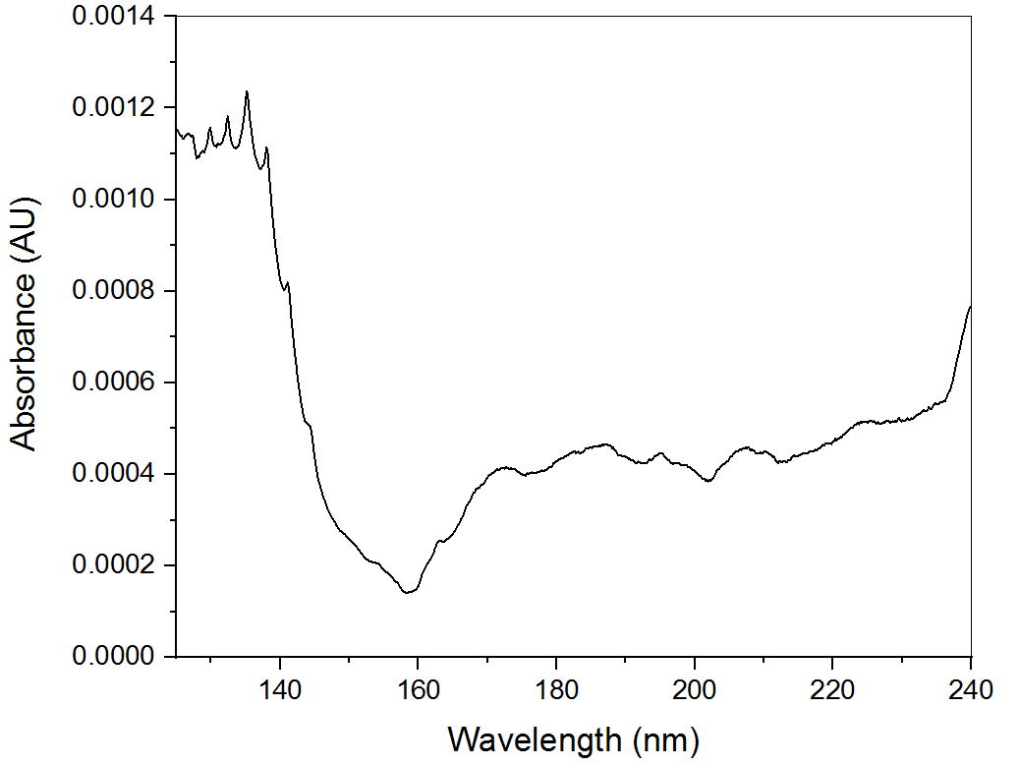

Figure S3 Detector blank signal.

Table S1 Composition of standard mixture in toluene for investigation of the limits of detection of the GC×GC/VUV method.

|  |  |
| --- | --- |
| Compound | m/m% in solution |
| n-C8 | 1.07 |
| n-C10 | 1.14 |
| n-C12 | 0.96 |
| n-C14 | 1.07 |
| n-C16 | 1.07 |
| n-C17 | 1.26 |
| n-C18 | 1.03 |
| 1,13-tetradecadiene | 1.07 |
| 1,2-cyclooctadiene | 1.05 |
| *trans*-2-octene | 1.06 |
| 1,7 octadiene | 1.00 |
| *cis*-decalin | 0.59 |
| *trans*-decalin | 0.70 |
| 1-decene | 1.54 |
| 1-undecene | 0.97 |
| 1,3,5-trimethylbenzene | 1.06 |
| 1,2,3-trimethylbenzene | 1.36 |
| 1-phenyldecane | 0.84 |
| 1-phenyldodecane | 0.89 |
| *m*-xylene | 1.19 |
| Propylbenzene | 1.09 |

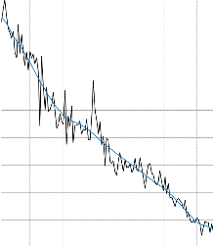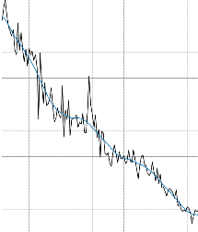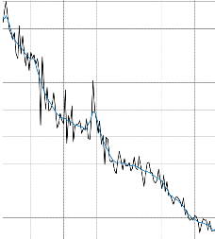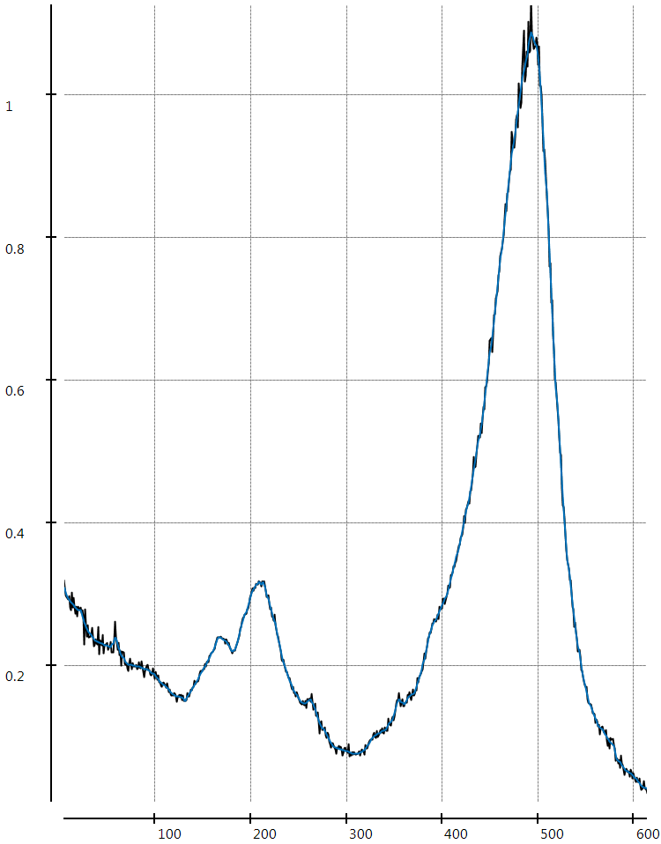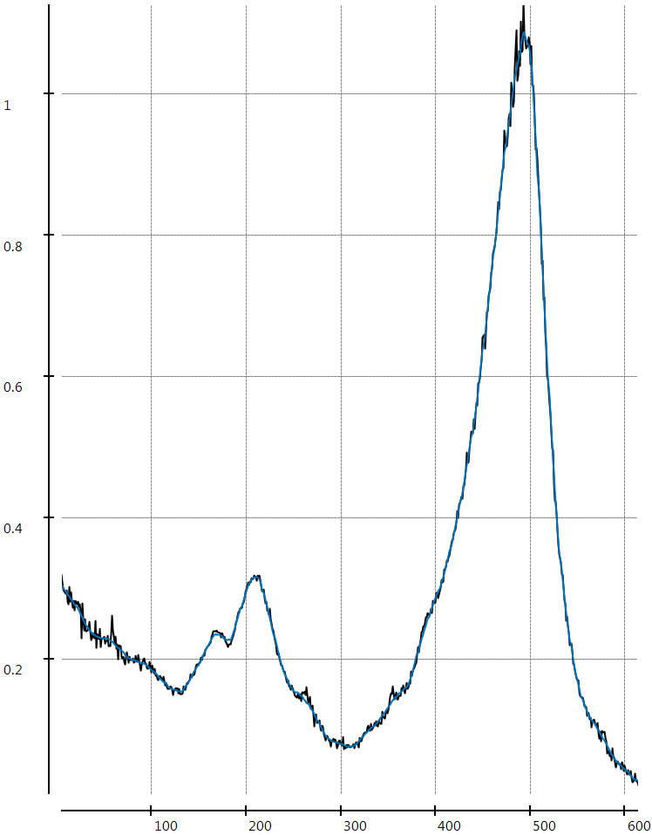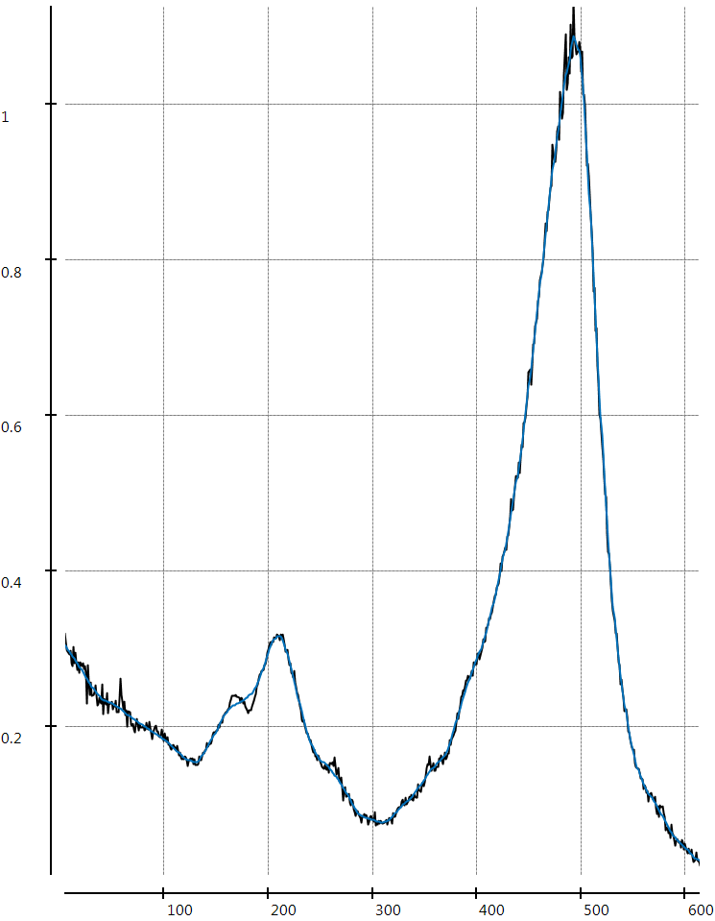

A

B

C

Figure S4 Spectrum at a chosen chromatogram point (in grey) smoothed by choosing following filter M values (in blue) (A) 5, (B) 15, (C) 20.

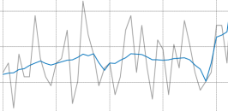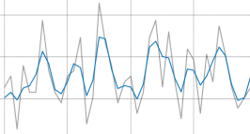 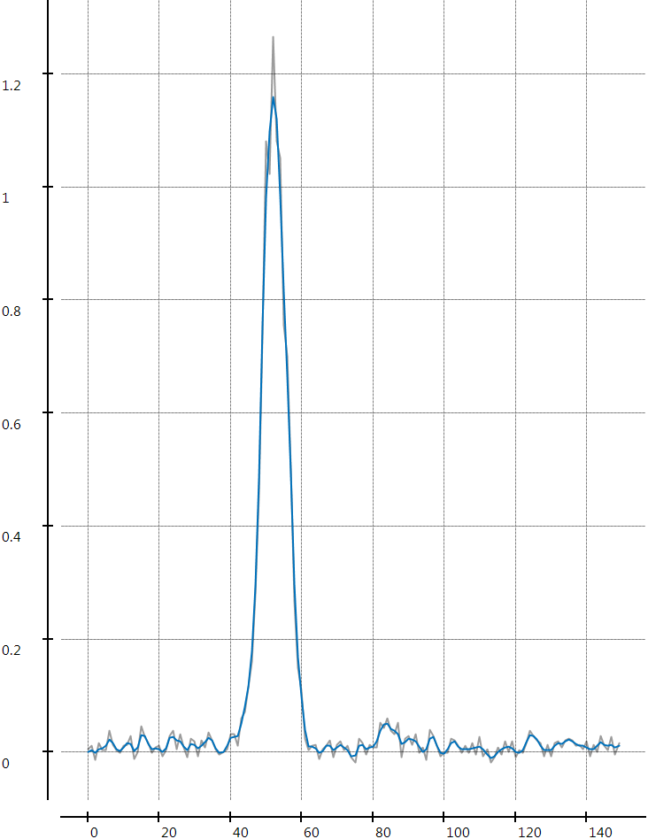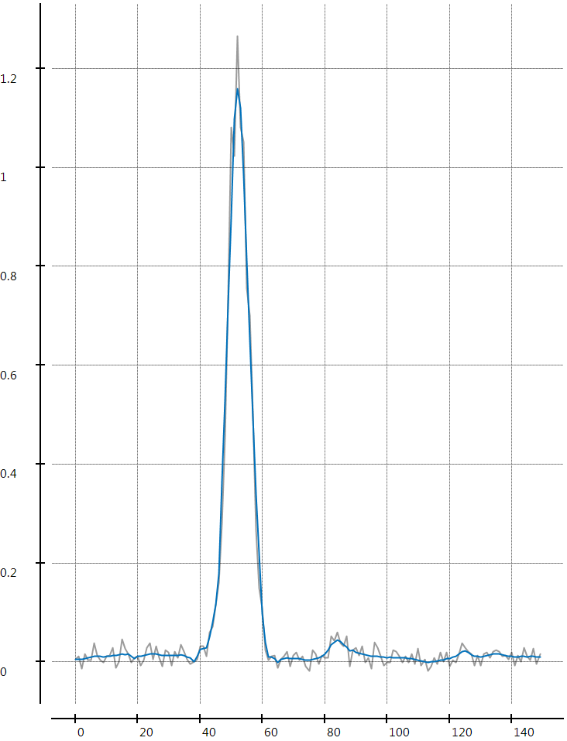

B

A

Figure S5 Illustration of the noise correction: input signal in grey and resultant signal in blue. Noise filter M value (A) 2, (B) 5. One modulation period 125 nm chromatogram is shown.

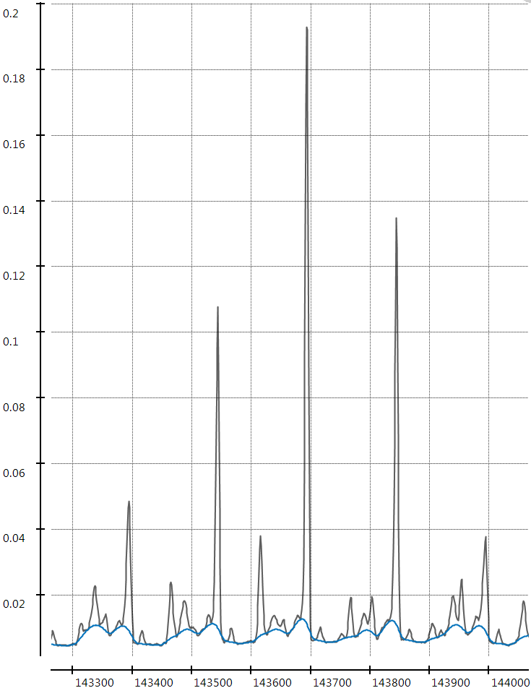 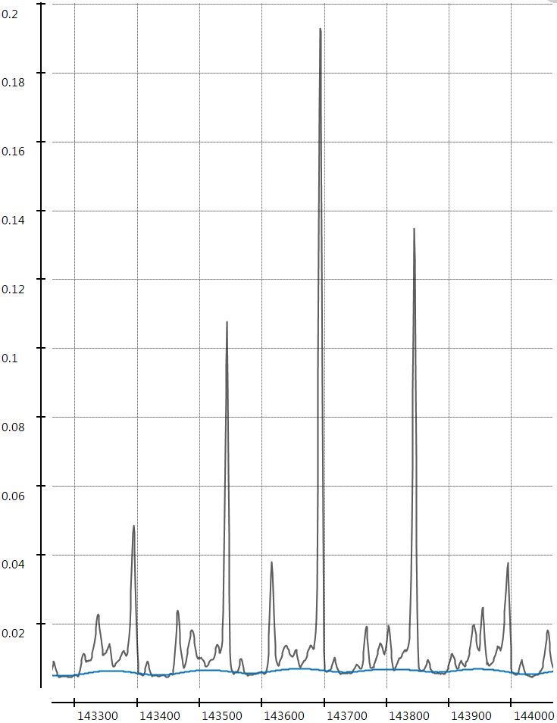 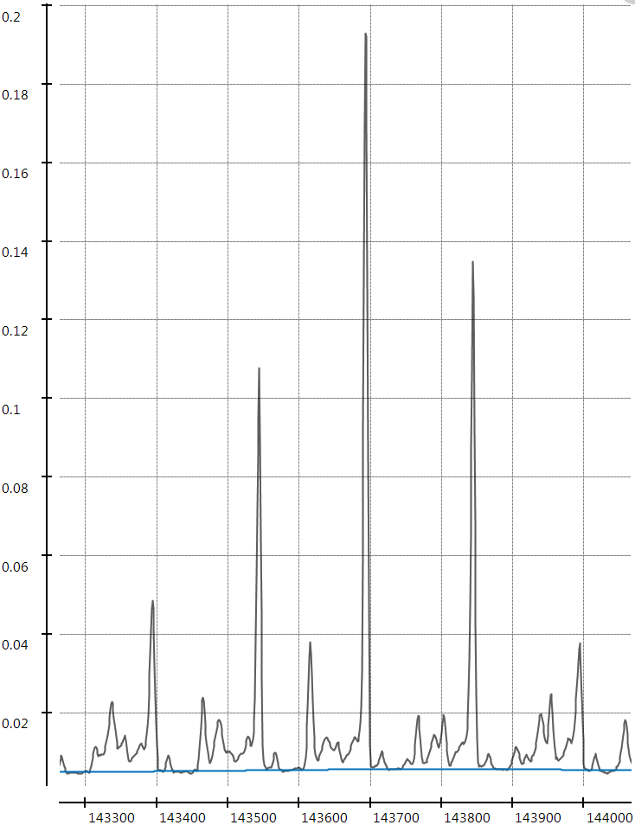

C

B

A

Figure S6 Estimated baseline (in blue) for a VUV signal (in grey) depending on the chosen convolution kernel sizes; (A) 5, (B) 20, (C) 100, number of iterations is 15 (125 nm).

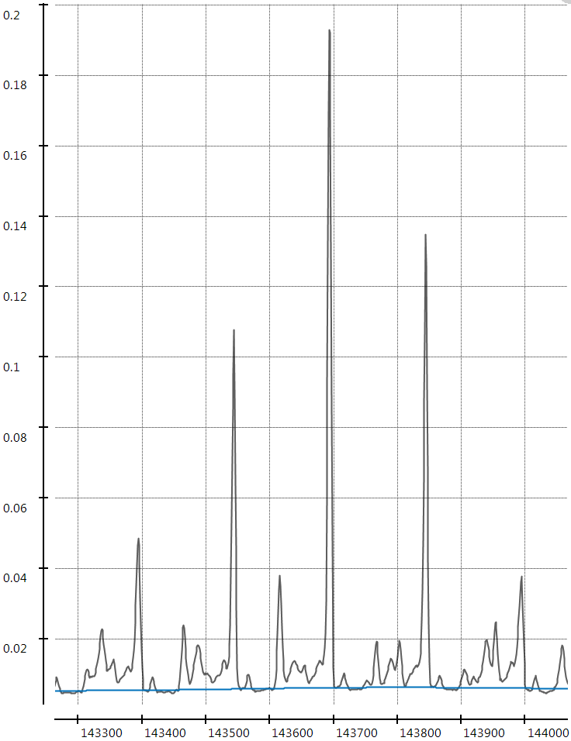 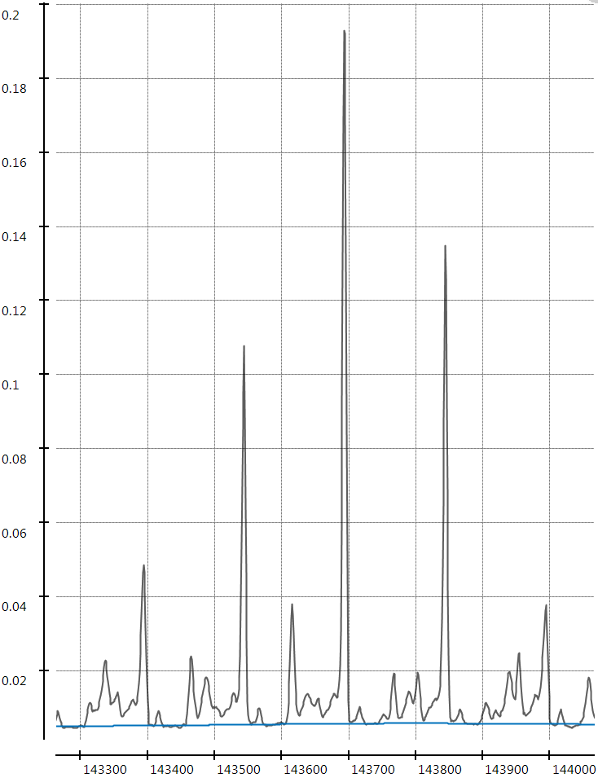 

C

B

A

Figure S7 Estimated baseline (in blue) for a VUV signal (in grey) depending on the chosen number iterations; (A) 5, (B) 10, (C) 15, convolution kernel size is 100 (125 nm).

Table S2 Estimation of spectral similarity with corresponding VUV library spectrum - test mixture 150 x dilution.

|  |  |  |  |  |
| --- | --- | --- | --- | --- |
| Compound | No preprocessing | | With preprocessing | |
| **Chi2** | **R2** | **Chi2** | **R2** |
| **n-decane** | 0.008170 | 0.48 | 0.001530 | 0.96 |
| **1-decene** | 0.002730 | 0.87 | 0.000836 | 0.97 |
| **m-xylene** | 0.010200 | 0.61 | 0.000474 | 0.98 |

Table S3 Peak volume and signal to noise ratio for selected peaks, for different dilutions of the test mixture with baseline correction in GC Image. GC Image was used for integration of Avg. 125-240 nm chromatogram.

|  |  |  |  |  |  |  |  |  |  |  |  |  |  |  |  |
| --- | --- | --- | --- | --- | --- | --- | --- | --- | --- | --- | --- | --- | --- | --- | --- |
| Compound | Conc (ppm) | Blob volume | S/N | Conc (ppm) | Blob volume | S/N | Conc (ppm) | Blob volume | S/N | Conc (ppm) | Blob volume | S/N | Conc (ppm) | Blob volume | S/N |
| n-C10 | 11400 | 11.54 | 2214.63 | 5770 | 6.20 | 1147.38 | 1238 | 1.41 | 280.33 | 571 | 0.65 | 135.85 | 251 | 0.33 | 57.46 |
| n-C12 | 9600 | 4.59 | 1122.90 | 4859 | 2.46 | 680.08 | 1042 | 0.56 | 235.26 | 481 | 0.28 | 112.96 | 211 | 0.13 | 46.00 |
| n-C14 | 10700 | 5.01 | 1484.44 | 5416 | 2.65 | 917.50 | 1162 | 0.63 | 280.78 | 536 | 0.29 | 123.66 | 235 | 0.13 | 50.59 |
| n-C16 | 10700 | 4.90 | 1050.22 | 5416 | 2.64 | 847.81 | 1162 | 0.59 | 294.33 | 536 | 0.30 | 111.33 | 235 | 0.15 | 56.85 |
| n-C17 | 12600 | 5.85 | 1658.04 | 6378 | 3.16 | 969.53 | 1368 | 0.69 | 350.43 | 631 | 0.34 | 162.32 | 277 | 0.17 | 87.47 |
| n-C18 | 10300 | 4.85 | 1122.15 | 5213 | 2.65 | 968.00 | 1118 | 0.59 | 254.27 | 516 | 0.29 | 162.41 | 226 | 0.13 | 52.61 |
| 1-decene | 15400 | 16.77 | 3167.40 | 7795 | 9.17 | 1914.10 | 1672 | 1.98 | 484.52 | 772 | 0.94 | 292.33 | 338 | 0.46 | 119.76 |
| 1-undecene | 9700 | 6.07 | 1783.45 | 4910 | 3.33 | 1058.84 | 1053 | 0.72 | 229.03 | 486 | 0.34 | 137.06 | 213 | 0.17 | 59.26 |
| m-xylene | 11900 | 15.63 | 3478.45 | 6023 | 8.62 | 2395.94 | 1292 | 1.87 | 551.68 | 596 | 0.85 | 287.17 | 261 | 0.39 | 114.49 |
| Propylbenzene | 10900 | 13.18 | 2572.56 | 5517 | 7.20 | 1887.33 | 1183 | 1.59 | 558.55 | 546 | 0.73 | 282.18 | 240 | 0.33 | 121.60 |
| 1,3,5-trimethylbenzene | 10600 | 13.90 | 3075.52 | 5365 | 7.58 | 2023.89 | 1151 | 1.64 | 607.21 | 531 | 0.78 | 260.15 | 233 | 0.37 | 110.20 |
| 1,2,3-trimethylbenzene | 13600 | 14.92 | 3066.36 | 6884 | 8.25 | 2206.04 | 1477 | 1.77 | 591.59 | 682 | 0.85 | 259.77 | 299 | 0.38 | 112.28 |
| *trans*-decalin | 7000 | 2.89 | 773.79 | 3543 | 1.58 | 496.78 | 760 | 0.35 | 100.73 | 351 | 0.16 | 53.80 | 154 | 0.09 | 26.68 |
| *cis*-decalin | 5900 | 2.46 | 642.82 | 2986 | 1.35 | 397.74 | 641 | 0.32 | 78.37 | 296 | 0.14 | 47.94 | 130 | 0.08 | 21.73 |
| 1-phenyldecane | 8400 | 6.84 | 2040.22 | 4252 | 3.77 | 1245.21 | 912 | 0.81 | 357.23 | 421 | 0.39 | 200.63 | 185 | 0.19 | 73.10 |
| 1-phenyldodecane | 8900 | 6.99 | 1821.50 | 4505 | 3.77 | 1415.59 | 966 | 0.83 | 365.46 | 446 | 0.39 | 155.85 | 196 | 0.19 | 69.32 |
| 1,2-cyclooctadiene | 10500 | 9.38 | 2171.68 | 5315 | 5.00 | 1304.07 | 1140 | 1.08 | 256.46 | 526 | 0.51 | 152.18 | 231 | 0.28 | 65.33 |
| 1,13-tetradecadiene | 10700 | 7.56 | 2311.23 | 5416 | 4.10 | 1687.16 | 1162 | 0.89 | 399.65 | 536 | 0.42 | 176.76 | 235 | 0.22 | 79.22 |
| Compound | Conc (ppm) | Blob volume | S/N | Conc (ppm) | Blob volume | S/N | Conc (ppm) | Blob volume | S/N | Conc (ppm) | Blob volume | S/N | Conc (ppm) | Blob volume | S/N |
| n-C10 | 121.4 | 0.17 | 28.78 | 81.98 | 0.13 | 21.17 | 64.64 | 0.11 | 17.16 | 39.37 | 0.07 | 11.16 | 25.25 | 0.06 | 7.27 |
| n-C12 | 102.2 | 0.05 | 19.93 | 69.04 | 0.07 | 14.62 | 54.43 | 0.03 | 6.92 | 33.16 | 0.02 | 6.26 | 21.26 | 0.02 | 5.87 |
| n-C14 | 113.9 | 0.08 | 24.08 | 76.95 | 0.04 | 14.49 | 60.67 | 0.04 | 9.94 | 36.95 | 0.04 | 8.29 | 23.70 | 0.02 | 5.68 |
| n-C16 | 113.9 | 0.07 | 28.02 | 76.95 | 0.05 | 19.18 | 60.67 | 0.05 | 14.95 | 36.95 | 0.02 | 8.14 | 23.70 | 0.02 | 6.28 |
| n-C17 | 134.2 | 0.10 | 40.27 | 90.61 | 0.06 | 28.39 | 71.44 | 0.06 | 17.77 | 43.52 | 0.04 | 13.66 | 27.91 | 0.03 | 6.59 |
| n-C18 | 109.7 | 0.07 | 23.50 | 74.07 | 0.06 | 20.37 | 58.40 | 0.04 | 12.07 | 35.57 | 0.03 | 10.96 | 22.81 | 0.04 | 6.55 |
| 1-decene | 164.0 | 0.22 | 44.03 | 110.75 | 0.15 | 36.04 | 87.32 | 0.12 | 27.06 | 53.19 | 0.07 | 12.08 | 34.11 | 0.06 | 8.50 |
| 1-undecene | 103.3 | 0.06 | 20.10 | 69.76 | 0.05 | 12.08 | 55.00 | 0.03 | 9.23 | 33.50 | 0.03 | 5.66 | 21.49 | 0.00 |  |
| m-xylene | 126.7 | 0.21 | 45.71 | 85.58 | 0.17 | 34.87 | 67.47 | 0.10 | 22.00 | 41.10 | 0.08 | 18.19 | 26.36 | 0.04 | 9.80 |
| Propylbenzene | 116.1 | 0.16 | 50.17 | 78.39 | 0.11 | 31.71 | 61.80 | 0.09 | 23.80 | 37.65 | 0.06 | 12.06 | 24.14 | 0.02 | 7.71 |
| 1,3,5-trimethylbenzene | 112.9 | 0.19 | 43.29 | 76.23 | 0.12 | 30.32 | 60.10 | 0.10 | 24.51 | 36.61 | 0.06 | 15.55 | 23.48 | 0.03 | 7.19 |
| 1,2,3-trimethylbenzene | 144.8 | 0.17 | 52.74 | 97.80 | 0.12 | 35.56 | 77.11 | 0.08 | 24.44 | 46.97 | 0.07 | 16.66 | 30.12 | 0.03 | 7.33 |
| *trans*-decalin | 74.5 | 0.04 | 10.15 | 50.34 | 0.02 | 8.57 | 39.69 | 0.03 | 7.80 | 24.18 | 0.02 | 4.61 | 15.51 | 0.00 | 6.04 |
| *cis*-decalin | 62.8 | 0.03 | 11.94 | 42.43 | 0.02 | 8.83 | 33.45 | 0.02 | 6.46 | 20.38 | 0.01 | 4.39 | 13.07 | 0.00 | 5.29 |
| 1-phenyldecane | 89.4 | 0.09 | 34.62 | 60.41 | 0.07 | 23.32 | 47.63 | 0.04 | 16.89 | 29.01 | 0.03 | 9.85 | 18.61 | 0.02 | 7.73 |
| 1-phenyldodecane | 94.8 | 0.09 | 33.19 | 64.00 | 0.06 | 19.77 | 50.46 | 0.04 | 12.27 | 30.74 | 0.03 | 7.81 | 19.71 | 0.03 | 6.23 |
| 1,2-cyclooctadiene | 111.8 | 0.11 | 30.37 | 75.51 | 0.08 | 20.03 | 59.54 | 0.07 | 12.19 | 36.26 | 0.03 | 7.87 | 23.26 | 0.03 | 7.31 |
| 1,13-tetradecadiene | 113.9 | 0.10 | 37.28 | 76.95 | 0.08 | 27.16 | 60.67 | 0.05 | 20.10 | 36.95 | 0.04 | 11.07 | 23.70 | 0.03 | 7.79 |

Table S4 Peak volume and signal to noise ratio for selected peaks, for different dilutions of the test mixture with preprocessing in plug im! software (noise, baseline correction and detector blank subtraction). GC Image was used for integration of Avg. 125-240 nm chromatogram.

|  |  |  |  |  |  |  |  |  |  |  |  |  |  |  |  |
| --- | --- | --- | --- | --- | --- | --- | --- | --- | --- | --- | --- | --- | --- | --- | --- |
| Compound | Conc (ppm)* | Blob volume | S/N | Conc (ppm) | Blob volume | S/N | Conc (ppm) | Blob volume | S/N | Conc (ppm) | Blob volume | S/N | Conc (ppm) | Blob volume | S/N |
| n-C10 | 11400 | 12.32 | 10146.80 | 5770 | 6.64 | 6750.49 | 1238 | 1.52 | 2032.03 | 571 | 0.72 | 884.71 | 251 | 0.44 | 462.64 |
| n-C12 | 9600 | 4.88 | 6937.21 | 4859 | 2.70 | 4574.22 | 1042 | 0.63 | 1419.38 | 481 | 0.33 | 702.99 | 211 | 0.17 | 332.55 |
| n-C14 | 10700 | 5.48 | 7550.75 | 5416 | 2.82 | 5527.42 | 1162 | 0.68 | 1341.73 | 536 | 0.34 | 761.13 | 235 | 0.16 | 297.42 |
| n-C16 | 10700 | 5.07 | 6177.10 | 5416 | 2.79 | 4789.25 | 1162 | 0.64 | 1899.53 | 536 | 0.35 | 689.09 | 235 | 0.18 | 370.86 |
| n-C17 | 12600 | 6.06 | 7815.90 | 6378 | 3.25 | 4361.52 | 1368 | 0.74 | 1698.04 | 631 | 0.36 | 613.32 | 277 | 0.21 | 465.15 |
| n-C18 | 10300 | 4.96 | 7377.31 | 5213 | 2.73 | 5190.62 | 1118 | 0.66 | 1416.61 | 516 | 0.34 | 624.20 | 226 | 0.16 | 316.81 |
| 1-decene | 15400 | 7.25 | 11995.34 | 7795 | 9.44 | 12148.47 | 1672 | 2.11 | 3302.40 | 772 | 1.06 | 1951.60 | 338 | 0.55 | 867.24 |
| 1-undecene | 9700 | 7.22 | 11506.68 | 4910 | 3.55 | 6845.71 | 1053 | 0.81 | 1231.01 | 486 | 0.38 | 879.22 | 213 | 0.22 | 346.71 |
| m-xylene | 11900 | 7.99 | 12667.19 | 6023 | 9.10 | 14171.27 | 1292 | 1.97 | 3041.43 | 596 | 0.94 | 2299.64 | 261 | 0.45 | 616.58 |
| Propylbenzene | 10900 | 6.44 | 11269.94 | 5517 | 7.71 | 12197.06 | 1183 | 1.70 | 3101.11 | 546 | 0.82 | 1741.96 | 240 | 0.39 | 722.42 |
| 1,3,5-trimethylbenzene | 10600 | 17.44 | 15028.42 | 5365 | 8.84 | 12930.31 | 1151 | 1.90 | 4016.70 | 531 | 0.97 | 1661.07 | 233 | 0.44 | 933.01 |
| 1,2,3-trimethylbenzene | 13600 | 3.10 | 6467.49 | 6884 | 7.94 | 12848.24 | 1477 | 1.81 | 3441.14 | 682 | 0.89 | 1655.29 | 299 | 0.43 | 682.90 |
| *trans*-decalin | 7000 | 2.62 | 3789.06 | 3543 | 1.70 | 3138.50 | 760 | 0.40 | 550.18 | 351 | 0.21 | 366.57 | 154 | 0.14 | 166.04 |
| *cis*-decalin | 5900 | 15.82 | 20950.58 | 2986 | 1.43 | 2819.71 | 641 | 0.36 | 418.80 | 296 | 0.19 | 281.52 | 130 | 0.10 | 131.11 |
| 1-phenyldecane | 8400 | 14.38 | 15829.45 | 4252 | 4.03 | 6629.14 | 912 | 0.91 | 1935.31 | 421 | 0.44 | 1018.36 | 185 | 0.24 | 469.11 |
| 1-phenyldodecane | 8900 | 14.10 | 14534.28 | 4505 | 3.94 | 7912.15 | 966 | 0.92 | 2479.57 | 446 | 0.43 | 801.70 | 196 | 0.23 | 425.39 |
| 1,2-cyclooctadiene | 10500 | 10.05 | 12620.19 | 5315 | 5.25 | 8248.81 | 1140 | 1.14 | 1429.86 | 526 | 0.59 | 1080.24 | 231 | 0.34 | 405.50 |
| 1,13-tetradecadiene | 10700 | 16.47 | 19964.52 | 5416 | 4.49 | 10182.49 | 1162 | 0.97 | 2176.97 | 536 | 0.48 | 1234.71 | 235 | 0.27 | 486.49 |
| Compound | Conc (ppm) | Blob volume | S/N | Conc (ppm) | Blob volume | S/N | Conc (ppm) | Blob volume | S/N | Conc (ppm) | Blob volume | S/N | Conc (ppm) | Blob volume | S/N |
| n-C10 | 121.4 | 0.21 | 200.64 | 81.98 | 0.16 | 167.22 | 64.64 | 0.20 | 110.00 | 39.37 | 0.07 | 73.87 | 25.25 | 0.00 |  |
| n-C12 | 102.2 | 0.07 | 115.54 | 69.04 | 0.08 | 74.94 | 54.43 | 0.06 | 46.51 | 33.16 | 0.03 | 37.47 | 21.26 | 0.05 | 27.19 |
| n-C14 | 113.9 | 0.13 | 164.23 | 76.95 | 0.06 | 74.78 | 60.67 | 0.07 | 54.58 | 36.95 | 0.06 | 46.37 | 23.70 | 0.08 | 29.71 |
| n-C16 | 113.9 | 0.11 | 174.38 | 76.95 | 0.09 | 113.75 | 60.67 | 0.10 | 80.15 | 36.95 | 0.05 | 49.65 | 23.70 | 0.05 | 25.59 |
| n-C17 | 134.2 | 0.13 | 196.66 | 90.61 | 0.10 | 150.95 | 71.44 | 0.08 | 93.77 | 43.52 | 0.06 | 70.81 | 27.91 | 0.02 | 20.49 |
| n-C18 | 109.7 | 0.09 | 131.06 | 74.07 | 0.08 | 147.08 | 58.40 | 0.06 | 74.34 | 35.57 | 0.07 | 57.09 | 22.81 | 0.02 | 26.58 |
| 1-decene | 164.0 | 0.26 | 313.12 | 110.75 | 0.19 | 246.48 | 87.32 | 0.17 | 175.41 | 53.19 | 0.11 | 116.02 | 34.11 | 0.10 | 60.21 |
| 1-undecene | 103.3 | 0.10 | 129.24 | 69.76 | 0.07 | 71.78 | 55.00 | 0.05 | 52.48 | 33.50 | 0.06 | 44.92 | 21.49 | 0.04 | 28.24 |
| m-xylene | 126.7 | 0.27 | 333.19 | 85.58 | 0.22 | 199.27 | 67.47 | 0.14 | 140.90 | 41.10 | 0.11 | 114.86 | 26.36 | 0.07 | 69.40 |
| Propylbenzene | 116.1 | 0.22 | 341.12 | 78.39 | 0.16 | 215.14 | 61.80 | 0.12 | 142.46 | 37.65 | 0.08 | 73.42 | 24.14 | 0.05 | 42.85 |
| 1,3,5-trimethylbenzene | 112.9 | 0.23 | 298.26 | 76.23 | 0.14 | 215.10 | 60.10 | 0.12 | 161.49 | 36.61 | 0.13 | 95.32 | 23.48 | 0.02 | 16.39 |
| 1,2,3-trimethylbenzene | 144.8 | 0.27 | 279.86 | 97.80 | 0.19 | 210.57 | 77.11 | 0.14 | 148.90 | 46.97 | 0.12 | 93.17 | 30.12 | 0.07 | 33.97 |
| *trans*-decalin | 74.5 | 0.08 | 82.85 | 50.34 | 0.05 | 52.65 | 39.69 | 0.05 | 47.40 | 24.18 | 0.03 | 30.74 | 15.51 | 0.02 | 20.77 |
| *cis*-decalin | 62.8 | 0.07 | 80.38 | 42.43 | 0.05 | 58.05 | 33.45 | 0.07 | 32.99 | 20.38 | 0.03 | 25.17 | 13.07 | 0.04 | 19.82 |
| 1-phenyldecane | 89.4 | 0.14 | 207.39 | 60.41 | 0.10 | 133.76 | 47.63 | 0.10 | 84.03 | 29.01 | 0.05 | 51.30 | 18.61 | 0.06 | 24.29 |
| 1-phenyldodecane | 94.8 | 0.13 | 164.04 | 64.00 | 0.08 | 121.18 | 50.46 | 0.09 | 70.28 | 30.74 | 0.06 | 46.84 | 19.71 | 0.06 | 39.40 |
| 1,2-cyclooctadiene | 111.8 | 0.16 | 207.64 | 75.51 | 0.14 | 119.11 | 59.54 | 0.10 | 85.26 | 36.26 | 0.10 | 47.78 | 23.26 | 0.05 | 35.51 |
| 1,13-tetradecadiene | 113.9 | 0.15 | 223.72 | 76.95 | 0.11 | 153.79 | 60.67 | 0.08 | 112.60 | 36.95 | 0.09 | 70.54 | 23.70 | 0.08 | 33.75 |

* At this level detector saturation could be present.

Table S5 Estimation of spectral similarity with corresponding VUV library spectrum - test mixture 500 x dilution.

|  |  |  |  |  |
| --- | --- | --- | --- | --- |
| Compound | No preprocessing | | With preprocessing | |
| **Chi2** | **R2** | **Chi2** | **R2** |
| **m-xylene** | 0.007580 | 0.25 | 0.001640 | 0.94 |